**SWOT Analysis**

In order to devise an effective strategy to move forward in any entrepreneur endeavor, you need to understand your own situation and the world around you through an objective analysis or ‘reality check’. Examine each category as it relates to your project, practice, or proposed business idea as they stand right now. You’re not predicting the future.

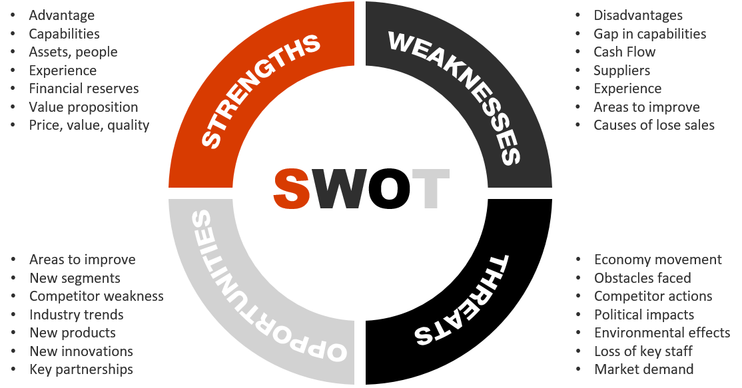



**SWOT Analysis**

Modify the chart as you see fit to complete a thorough SWOT Analysis. Use bullets.

|  |  |
| --- | --- |
| **STRENGTHS** | **WEAKNESSES** |
|  |  |
| **OPPORTUNITIES** | **THREATS** |
|  |  |

Answer the following questions:

1. What elements of the entrepreneurial mindset appeal to you? Which ones concern you?
2. What business would you like to explore starting during this workshop?
3. What vision, mission and values will guide your business or creative enterprise? How will they be a unique reflection of you?  
     
   A mission statement communicates the purpose of your business, your company, your organization, your project, or your creative endeavor.

The vision statement provides insight into what the company hopes to achieve or become in the future. It’s aspirational.

Your values reflect your or your business’ core principles and ethics. They are what you stand for.