CREATIVE ENTREPRENEURSHIP

ASSIGNMENT #4: YOU CHOOSE OPTION 1 or OPTION 2

OPTION 1: COSTUME BID

Read this request for a bid. Identify your scope of work and all possible expense items you would incur to complete the project. Determine what you would charge and itemized how you arrived at this number. Your bid must be professionally presented in a document and include: cost of materials, cost of labor, cost of overhead, profit, and a timeline. Describe your terms of payment.

Production Company: Morris Theatrical Ventures
Venue: Broadway
Show: She Loves Me
Performers: 6 dancers

You are a freelance draper working out of your home where you currently reside.

You can assume that the cost of your rent and utilities where you live is $1200/month. This includes heat, water, and electricity.

As an alternative, you can use the expenses you estimated in Assignment #3 for your start -up budget to calculate your overhead.

You will need to subcontract some of your work if you get this job. You would need to hire one assistant at $24/hour and two stitchers $18/hour each as independent contractors.

Please submit a bid for the 6 costumes shown below. The girls will be dancing in them so they need plenty of movement. There will be a quick change into them. They are lined and expected to have all the finishing techniques consistent with a costume that will survive the run of the show (4 months, 8 shows per week). Fashion fabric will be provided but linings, thread, closures, and interlinings will not.

.
OPTION 2: KILCODO COSTUMES TERMS OF SERVICE REVIEW

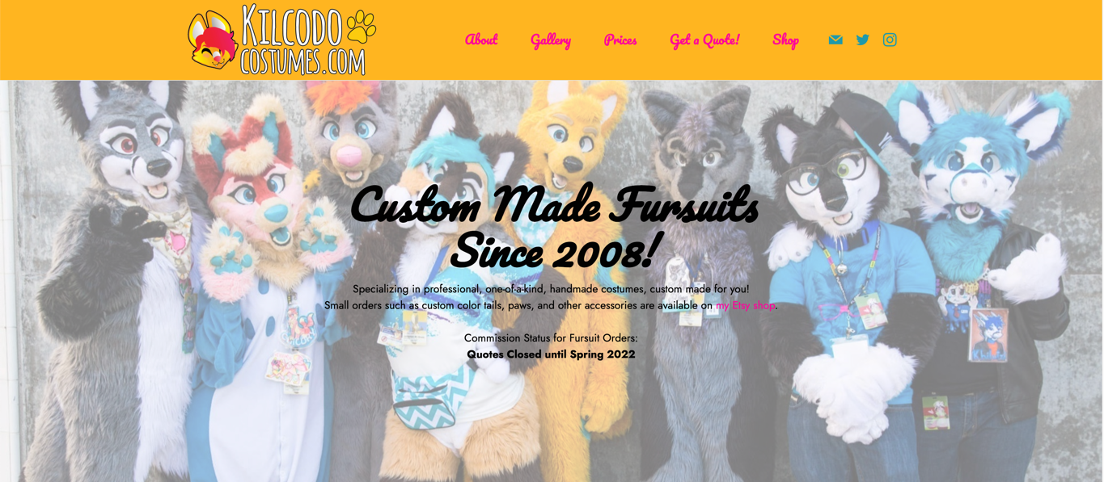

Below and here are the detailed Terms of Service Policy of KilcodoCostumes.com. For the purposes of this assignment, they are a competitor of yours. Read the entire policy, copy to a new document and mark up in red font or bold black text your detailed suggestions, changes, and opinions on each and every clause/item/provision in this policy according to the following criteria:
- Is this a realistic provision for you as a self-employed professional or business owner? Why or why not?
- What objections would a potential client or customer have to this provision?
- How would you amend this provision to make it more appealing to and flexible for the client/customer while still protecting your interests?
******************************************************************************
KILCODO COSTUMES TERMS OF SERVICE POLICY
Please read this document BEFORE you decide to purchase services/goods from Kilcodo Costumes. You are encouraged to save this document for your records.
The following policies are valid from September 2021 forward:
PAYMENTS
- Kilcodo Costumes only accepts payments from clients who are over the age of eighteen, or a consenting adult parent/guardian of clients who are minors.
- Payment is accepted in the form of PayPal, SquareCash, Zelle, Personal Checks, Money Orders or Western Union. If client chooses to send payment through mail, client assumes all responsibility for payment if it is lost in the mail. It is highly advised to keep all receipts and utilize certified mail when mailing payments.
- After your initial 30% Down-Payment/Deposit, the final 70% and the shipping costs are due within the deadline month. Payment plans can be negotiated, just ask!
- Though I do my best to send invoices ahead of time before a costume is completed, it is ultimately the client’s responsibility to make sure they receive their final invoice with enough time for completion and punctual delivery, so you can ask me for an updated balance at any time.
- Personal checks may take up to 10 days to process and this may affect the shipping time of your item if the check is sent close to costume completion.
- Your 30% Down-Payment (30% of the total price of the purchase not including shipping) is non-refundable unless Kilcodo Costumes cancels the contract. The artist reserves the right to cancel with a customer for any reason and will issue a full refund if this happens.
- If customer does not pay final 70% payment + shipping by 3 months of the costume's completion date, ownership of the costume will revert back to Kilcodo Costumes. Deposit will not be refunded. Obviously, each case is unique, so please contact us if you feel you cannot get your payment in within this time frame: if you have a family emergency or anything like that I can hold on to the costume for you for a negotiated amount of time.
- If you find you will be unable to pay your final payment in your deadline month, your costume can be put on hold for up to one year. This means that you have lost your space in queue and may have to wait longer to receive your costume, as you will be placed at the end of the queue. I am happy to work with clients who may need extra time to deliver their final payment amount.
- If client requests that work be put “on hold”, client understands that Kilcodo Costumes will hold the project in a back queue for one (1) year. If client does not contact Kilcodo Costumes within 1 year of initial hold request, the project is subject to cancellation or re-purposing of partially completed costume pieces.
- Upon purchase, client agrees NOT to deconstruct, take apart, or in any way damage the costume as a means of gaining knowledge on the methods of its creation. These costumes are works of art and are not meant to be tools to teach costume-making skills. Client also agrees NOT to sell the costume to any person who will deconstruct it in order to learn about its construction.
DUCT TAPE DUMMY AND MEASUREMENTS
- If you purchase a bodysuit, a duct-tape dummy is required. Your duct-tape-dummy must be made correctly in order for your costume’s final bodysuit to fit properly. A tutorial is available on the official website at kilcodocostumes.com/dtd.html. A poorly made bodysuit, where certain parts of the body are constricted too much by the tape, the arms are not held straight out from the body, areas are twisted by elastic or making the tape too tight, or made too short on the arms/legs will render a bodysuit with fit issues. I am not responsible for suits that fit poorly due to improper measuring or poorly made duct-tape-dummies and a bad fit due to a poorly made dummy is not covered by warranty. Your bodysuit will basically be a copy of your DTD.
- It is the customer’s responsibility to tape their duct-tape-dummies back together in the appropriate locations so the dummy’s pieces line up properly. Please cover all cut areas with tape and do not leave gaps. Dummies sent into the costume studio that are cut open and have not been taped back together may be sent back to the client or may incur a $25 Taping Fee.
- I will ask for measurements when a client purchases a custom-made fursuit head, gloves, costume feet or armsleeves/legsleeves. It is the client’s responsibility to take these measurements correctly. I am not responsible for poorly fitting items based on incorrect measurements.
SHIPPING
- Costumes will NOT be shipped out until this final payment + shipping is received and cleared, so please remember to have it READY on your deadline month! You will know when your costume is nearing completion as I will send you multiple updates and photographs along the way. Please ask for a detailed invoice if you do not receive one.
- Customers will pay a base shipping price (usually $50-90 in the U.S.) as part of their final deposit. However, if the shipment winds up costing more than this due to distance or weight, the customer is obligated to cover the difference. Kilcodo Costumes intentionally uses correctly-sized boxes and practices responsible shipping to avoid unnecessary postal fees, however sometimes higher prices cannot be avoided if the box contains additional weight (like larger than normal costume pieces) or is traveling a greater than normal distance. All shipments include tracking by default.
- For international customers: it is your responsibility to research your local customs taxes. If I am not informed otherwise, the full costume value will be listed on the package and your country may charge an additional tax on your item before they release it to you. Shipments can be split into two boxes for international orders if requested.
- Kilcodo Costumes is not responsible for late payments that may delay a shipment, this includes the process period of personal checks or e-checks. Items may ship the day after a payment is processed. Kilcodo Costumes uses FedEx Ground for domestic orders and USPS for international orders and express. Alternative carriers and shipment speeds can be used if requested, but may affect shipping price. Costumes will never be shipped without being 100% paid for. Buyer assumes all responsibility for keeping track of payments and invoices. If you have any concerns or questions about your balance, do not hesitate to contact me at: info@kilcodocostumes.com.
- Packages are typically NOT insured for their total costume price when shipped. If you’d like your package insured for the total value, please confirm with us before shipment. Keep in mind it may be difficult to provide the value of a handmade art item to a postal service if loss occurs.

QUOTES AND DEADLINES
- Price Quotes will expire after 30 days if a deposit is not received within that 30 day period. The later your deposit is entered, the later in the queue you will be.
- Date quoted by the company as a deadline is an estimate. I will do my very best to have costumes completed by the date promised. Deadlines are frequently updated on the queue page: kilcodocostumes.com/queue.html
- Placement in queue may be altered due to a personal injury, illness, family emergencies, etc. Clients must understand that Kilcodo, as an artist and an individual solely responsible for the creation of her work, reserves the right to shift and change deadlines for commissioned work due to these unforeseen circumstances and this does not entitle the client to an automatic efund. If such an incident occurs, Kilcodo will be transparent on social media services and through email so all clients know that their dates may have changed.
REFERENCES
- Reference material must be 100% accurate at time of deposit. Reference material can only be changed ONCE, and this must be sent to Kilcodo Costumes BEFORE work has started. Your reference must show the ENTIRE DESIGN in one image. If the character design changes, price may be re-negotiated to adjust for increase in complexity or added labor. Customers who change their species or costume design entirely after the deposit is received risk being placed later in the production queue. Kilcodo Costumes urges commissioners to have accurate reference material ready at time of receiving a quote from the company. Everything that is in your design reference will show up in your costume.
- Customers who wish to change their reference material more than once before work begins will pay a $10 “Reference Art Change Fee” per each additional change and must include an updated reference showing all of the changes accurately.
- Reference material is expected to be clear and easy to understand. The costume I create will be reflective of the consistency of the artwork or images provided as reference. I, the artist, am not responsible for cosmetic results on a costume based on a poor representation in your reference.
- If you have a design or feature on your reference sheet that is INACCURATE but do not change the reference or inform me of this change, and I create a costume piece based off of your inaccurate reference that needs to be entirely redone, there will be a labor charge for the time and energy spent on the inaccurate costume piece. These fees are as follows: $40 for tails, $50 for hand-paws, $75 for feetpaws, $100 for bodysuits, $300 for masks. These fees pay for the labor cost of an entirely new version of the costume piece as they will be remade.

ARTWORK PURCHASES
- If a client purchases an illustration, badge, sketch or digital drawing from Kilcodo Costumes, the client is purchasing the artwork for personal use. Image copyright will be retained by Kilcodo Costumes. This means that the client does NOT have the right to redistribute the artwork for profit in a commercial manner. Client is permitted to resell individual original works of art, but cannot sell copies of the work, or have the work reprinted and sold in mass quantities. Client cannot sell artwork to a company that wishes to use the artwork in a commercial or profiteering manner. Client cannot manipulate and use these images for personal use without giving credit to Kilcodo.
- Kilcodo reserves the right to charge extra for additional modifications made to artwork if deemed necessary. (For example: if a customer has a character erased and redrawn several times, it may be considered fair by the company to ask for additional compensation).
WARRANTY AND REFUNDS
- Kilcodo Costumes offers a 2-year warranty on repairs provided that they are NOT due to negligence, poorly made dtds or modification aside from small glue or thread repairs. This warranty includes *some* cosmetic repairs like repainting an area that has faded/been scratched. Kilcodo Costumes reserves the right to decline repairs if the costume is considered unsanitary or a health hazard. When sending a costume in for repairs, buyer must cover shipping costs. Package costume carefully so items will not become crushed or misshapen. Please clean your suit items thoroughly before you ship them to the studio.
- Kilcodo Costumes will NOT clean your costume as part of the warranty.
- Sizing alterations and cosmetic updates are not covered by warranty and regular labor charges apply.
- Lost costume items (items lost while in the care of the client) are not covered by warranty.
-Warranty is void if costume pieces have been put in hot water or on a warm or hot dryer cycle or left in a car or are in any way melted or damaged by heat.
- If past the 2 year deadline, alterations and repairs can be done for an hourly rate of $35/hr or a flat cost of labor fee, plus shipping, determined once severity of repair is analyzed.
- Adding new elements to costumes (like adding horns/wings, replacing anatomy, changing patterns/color of pieces) are not covered by warranty and may require a cost of labor/materials rate. Each case is different and may be negotiated personally.
- Custom fursuits, tails, and other personalized handmade pieces are non-refundable once created.
- There are no refunds on artwork which has already been started.

By ordering costume items or artwork from Kilcodo Costumes, buyer has agreed to these policies. Commissioners hold responsibility for the payment of and maintenance for their purchase. A care guide for costumes is available at kilcodocostumes.com/care.htm and customers will receive a small care pamphlet in the mail when the costume arrives.

